**Environmental Standards Scotland (ESS)**

**Representation form**



**Easy Read version**

**What is this form for?**

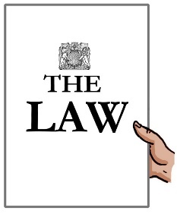

Use this form to tell Environmental Standards Scotland (ESS) that you believe a public authority (government department, local council etc) is not following the rules in place to protect the environment or that these rules are not working well. This is called your representation.



The information you give in this form will let us carry out an assessment and decide what action to take.



We may also wish to contact you for more information. If you have any difficulties completing this form, our staff are happy to help and can be emailed at [Representations@environmentalstandards.scot.](mailto:Representations@environmentalstandards.scot)

**Next steps**

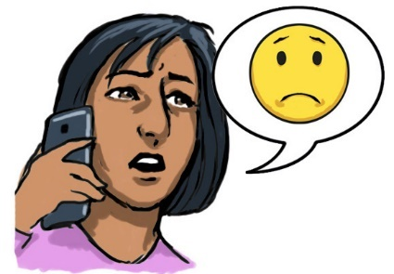

You should normally try to give the public authority the chance to respond to the issue before you report it to us.



We will write to you setting out any action we are taking and give the reasons for this.

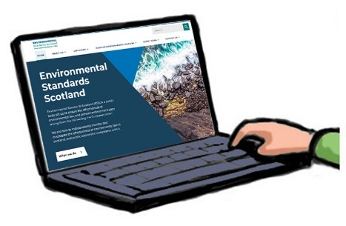

The ‘How to raise a concern’ and ‘Frequently Asked Questions’ pages on our website have further information that might help you fill in this form.



By submitting this form you agree to our Data Privacy Notice. ESS may use the information you give us but we will not share your personal information without consent from you. You may tell us at any time if you wish to withdraw your representation.



When you have completed this form, please send it to [Representations@environmentalstandards.scot.](mailto:Representations@environmentalstandards.scot)

**Section 1 – Your representation**



1. Please tell us the name of the public authority you are contacting us about in the box below.

Click or tap here to enter text.

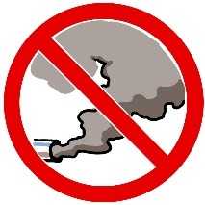

1. 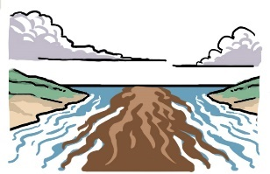What area of the environment is your representation about? (for example, air quality/pollution, water quality/pollution, contaminated land, nature conservation, protected sites, protected wildlife, climate change).

Click or tap here to enter text.



1. Have you already contacted the public authority about the matter?

Yes ☐ No ☐

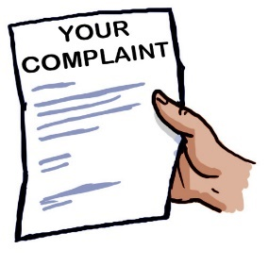

Have you had a response from them?

Yes ☐ No ☐

If the answer to either of the above questions is ‘no’, please tell us in the box below why this is the case.

Click or tap here to enter text.



1. Is your representation about:

A public authority not following an environmental law?

Yes ☐ No ☐ Don’t know ☐

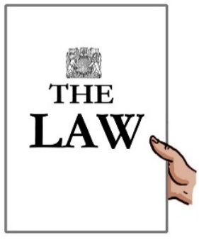

Environmental law not being carried out properly?

Yes ☐ No ☐ Don’t know ☐



An environmental law that is not protecting the environment?

Yes ☐ No ☐ Don’t know ☐

1. Please tell us in the box below what you want to report to us and why.

Click or tap here to enter text.



It would help us if you could give us copies of the public authority’s response to you and any supporting information you have.

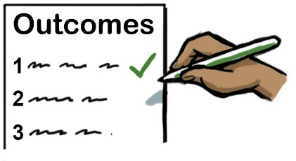

1. What outcome do you want from bringing your representation to ESS? An outcome is a result that you want to happen.

Click or tap here to enter text.



1. How did you hear about ESS?

Click or tap here to enter text.

**Section 2 – Your details**



The person who identified the problem should normally fill in this form. If you are acting for someone else, please make sure that they are happy for you to do so.

First Name

Click or tap here to enter text.

Click or tap here to enter text.

Last Name

Click or tap here to enter text.

Your Organisation’s name   
(if you have one)

Telephone Number

Click or tap here to enter text.

Email address

Click or tap here to enter text.

Address Line 1

Click or tap here to enter text.

Click or tap here to enter text.

Address Line 2

Click or tap here to enter text.

Town/City

Post Code

Click or tap here to enter text.

Click or tap here to enter text.

Preferred contact method



To investigate your concerns we normally need to contact the public authority. This means we may need to share personal information with them about your case.

**Diversity Monitoring**

ESS wants to make sure we are reaching as many people as possible and preventing barriers from using our service. We have an Equality and Diversity Monitoring Form available to all who submit a representation.



We understand that this information is personal. We would like you to share your details but it is up to you if you want to or not. It will not affect your representation.



All diversity information shared will be kept private in a secure database, separate from your representation.

**Declaration**



By completing and signing this form, I confirm that the information given is correct.

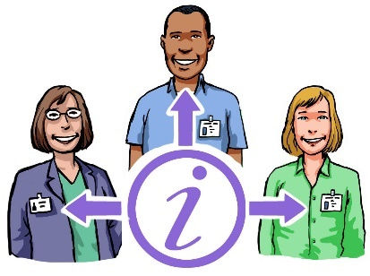

I also give my consent for ESS to share information about me with the public authority/authorities involved in the representation (please contact us if you have any concerns about this).



I also understand that ESS may use information about my concerns held by the public authority. This may include personal information. I also understand that my personal information will be kept by ESS in line with our privacy notice.

Click or tap here to enter text.

Click or tap here to enter text.

**Signature Date**

(Click image to   
add a digital   
signature file)

**Section 3 – Checklist**

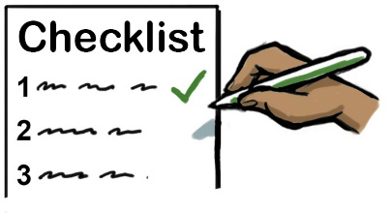

Have you fully completed all sections of the form that apply to you?

Yes ☐ No ☐



Have you included copies of all your supporting paperwork (in particular any response you got from the public authority)?

Yes ☐ No ☐



Please do not send us original documents. Any original documents you send will be returned. When our work comes to an end, the documents we hold on our files will be destroyed.



If you plan to send us large amounts of documents, please put your documents in date order, putting the most recent document at the front and oldest at the back.